Name: (Your Name) Collaborators: (Any one you worked with)

R Lab 1: Introduction to R and RStudio

Please answer all the Exercises and the questions from the “On Your Own” section. If you use any graphs or charts to justify your answer, please include them.

From the RStudio intro:
- What years are included in this data set? What are the dimensions of the data frame and what are the variable or column names?
  - Years range from 1940 to 2002
  - data has 63 rows, and 3 columns
  - column names are: year, boys, girls
- How do these counts compare to Arbuthnot’s? Are they on a similar scale?
  - See figure 2. The counts in Arbuthnot’s data are many orders of magnitude less than those of the data in the present frame. That being said, the relative differences between boys and girls appears to be rather consistent.
- Make a plot that displays the boy-to-girl ratio for every year in the data set. What do you see? Does Arbuthnot’s observation about boys being born in greater proportion than girls hold up in the U.S.? Include the plot in your response.
  - See figures 1 and 2
  - It does appear that boys generally outnumber girls according to baptism counts. As it seems very consistent that there’s a very slight, but consistent difference in the numbers seen for the genders.
- In what year did we see the most total number of births in the U.S.? You can refer to the help files or the R reference card http://cran.r-project.org/doc/contrib/Short-refcard.pdf to find helpful commands.
present[which((present$boys+present$girls)==max(present$boys+present$girls),arr.ind = TRUE),1:3]
year boys girls
1961 2186274 2082052

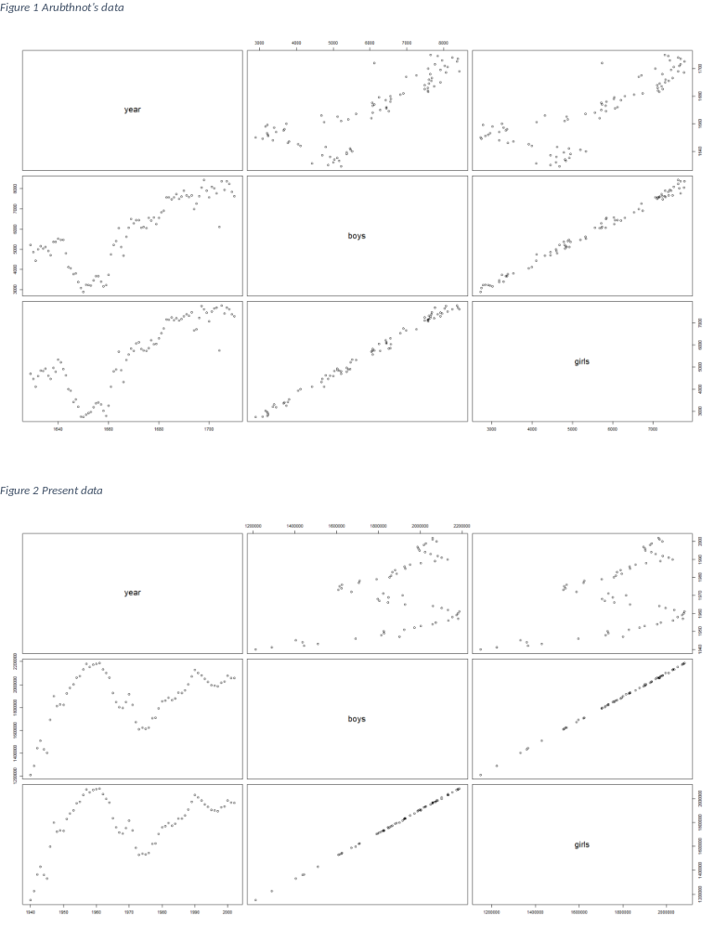

Exercise 1: What command would you use to extract just the counts of girls baptized?

- present$girls

Exercise 2: Is there an apparent trend in the number of girls baptized over the years?
How would you describe it?

- From what I can see, it appears that there was a major decline in the numbers of people being baptized through the 70’s but that trend bottomed out in 1973 and reversed starting in 1974.
It should also be noted that while the difference between boy and girl populations did vary year to year, it maintained a sort of constant relative margin over the entire lifetime of the data.

Exercise 3: Now, make a plot of the proportion of boys over time. What do you see?

The changes in the number of boys almost perfectly matches the changes in the number of girls.
Here’s the code I wrote to generate various plots used for this assignment. Note that the two plots I’ve included were the easiest to make. Simply type:
plot(arbuthnot)
plot(present)

DOC = "Build and plot the boys, girls, and the relative difference per year."
source("http://www.openintro.org/stat/data/present.R")
year = present$year
boy= present$boys

girl= present$girls

rel_boy =(boy+girl)/boy

rel_girl = (boy+girl)/girl

# Plotting data points from the Present data set.
par(mar = c(5,5,3,5))
plot(year,boy,type='l',ylab="boy and girl baptisms per year",
main="Present data, gendered baptisms plot",xlab='year',col='blue')
lines(year,girl,col='red')
par(new=TRUE)
# plot(year,bg_diff,type='l',xaxt='n',yaxt='n',ylab='',xlab='',lty=2)
plot(year, rel_girl,type='l',xaxt='n',yaxt='n',ylab='',xlab='',lty=2,col='orange')
lines(year,rel_boy ,xaxt='n',yaxt='n',ylab='',xlab='',lty=2,col='purple')
axis(side=4)
mtext('difference in boys and girls yearly baptism count',side=4,line=3)
legend("right", c("boys", "girls","relative girl count","relative boy count"),
col = c("blue", "red","orange","purple"), lty = c(1, 1, 2, 2))

plot(year, boy/girl,type='l',col='blue',ylim=c(.5,1.5))
lines(year, girl/boy,col='red')
lines(year,boy/boy)

pboy = boy
pgirl = girl
pyear = year

source("http://www.openintro.org/stat/data/arbuthnot.R")

year = arbuthnot$year
boy= arbuthnot$boys

girl= arbuthnot$girls

bg_diff = boy/max(boy+girl)

gb_diff = girl/max(boy+girl)
# plotting data points from the Arbothnot data set
par(mar = c(5,5,3,5))
plot(year,boy,type='l',ylab="boy and girl baptisms per year",
main="Arbothnot's data, gendered baptisms plot",xlab='year',col='blue')
lines(year,girl,col='red')
par(new=TRUE)
plot(year, gb_diff,type='l',xaxt='n',yaxt='n',ylab='',xlab='',lty=2,col='orange')
lines(year,bg_diff ,xaxt='n',yaxt='n',ylab='',xlab='',lty=2,col='purple')
axis(side=4)
mtext('difference in boys and girls yearly baptism count',side=4,line=3)
legend("right", c("boys", "girls","girls/max(girls+boys)","boys/max(boys+girls)"),
col = c("blue", "red","orange","purple"), lty = c(1, 1, 2,2))

plot(year, boy/girl,type='l',col='blue',ylim=c(.7,1.2))
lines(year, girl/boy,col='red')
lines(year,boy/boy)

plot(pyear,pgirl/pboy,type='b',ylim=c(-1.5,1.5),col="red",main="Boy to Girl Ratios for Present data")
par(new=TRUE)
plot(pyear, pboy/pgirl,type='b',xaxt='n',yaxt='n',ylab='',xlab='', col='blue')
lines(pyear,pgirl/pgirl,type='l',col="black")
legend("topright", c("girls", "boys"),
col = c("red","blue"), lty = c(1, 1))

scatter.smooth(pyear,pboy/pgirl,col="blue",yli=c(1.03,1.065),main="present boy/presentt girl ratio scatter.smooth")
scatter.smooth(pyear, pgirl/pboy, col='red',yli=c(.9,1),main="present gir/presentt boy ratio scatter.smooth")

plot(year, girl/boy, type='b',yli=c(-1.5,1.5),col='orange', main="Boy to Girl Ratios for Arbuthnot's data")
par(new=TRUE)
plot(year,boy/girl,type='b',xaxt='n',yaxt='n',ylab='',xlab='',lty=2,col='purple')
lines(year,boy/boy)
legend("topright", c("girls", "boys"),
col = c("orange","purple"), lty = c(1, 1))

scatter.smooth(year, girl/boy,type='b',lty=2,yli=c(.8,1.1),col='orange',main="present gir/presentt boy ratio scatter.smooth")
scatter.smooth(year,boy/girl,type='b',lty=2,col='purple',yli=c(.9,1.2),main="present boy/presentt girl ratio scatter.smooth")

plot(arbuthnot)
plot(present)

